INTRODUCTORY TEXT

One hundred years ago, animal experimentation was just as controversial as it is today. Scientists at universities across the country used animals to study disease, test drugs, research behavior, develop new surgeries, and train aspiring doctors. Critics of animal research, known then as antivivisectionists, condemned these practices on moral, ethical, and religious grounds. For both sides, humanity itself was at stake. Antivivisectionists maintained that animal experimentation compromised what makes us human, while physiologists insisted that these sacrifices were essential to medical progress and that neglecting to use animals to save human lives would be a moral failure. Both sides villainized the other with polarized rhetoric.
Chicago became a central battleground for these debates during the twentieth century. In 1929, when antivivisectionists introduced a bill designed to prohibit animal experimentation in Illinois, representatives from the four major Chicagoland medical schools banded together to form the Illinois Society of Medical Research (ISMR). Helmed by Dr. Anton J. Carlson, a pioneering physiologist and professor at the University of Chicago, and Dr. Andrew C. Ivy, his influential counterpart at Northwestern University, the organization assembled a powerful bloc of Chicago powerbrokers. Leading the antivivisectionists was Irene Castle McLaughlin, a celebrated dancer and doyenne of Chicago society. A friend of the newspaper tycoon William Randolph Hearst, Castle and her crusade against animal research were frontpage news for decades.
At the heart of the debates in Chicago were stray dogs. In 1931, the ISMR secured the passage of the Arvey Ordinance, which granted universities access to unclaimed pound dogs for experimental purposes. Dogs, more charismatic and familiar to the average citizen than mice or frogs, were a banner around which Chicago antivivisectionists rallied. The Arvey Ordinance formed a template for similar struggles across the United States (by 1966, ten states had similar “pound laws”) and Chicago became a symbol in ongoing disputes about the ethics and legal status of animal experimentation.
Drawing on ISMR records spanning five decades, this exhibition brings together correspondence, newspaper clippings, radio broadcasts, photographs, pamphlets, and propaganda to present both sides of a controversy that continues to shape the way we think about medical ethics and the cost of scientific progress.

CASE NO. 1: Origins
In the late-nineteenth century, French physiologist Claude Bernard argued that scientific progress required experimentation on living animals, also known as vivisection. Regarded as the father of experimental physiology, Bernard helped make animal experimentation—a practice dating back to the ancient world—central to research around the world. But he also inspired prominent objectors who gradually banded together to form the antivivisectionist movement.
In the United States, battles between scientists and antivivisectionists emerged in Los Angeles, St. Louis, and Philadelphia during the first decades of the twentieth century. Vivisection’s opponents adopted various tactics, including hiding animals and publicly criticizing scientists, and later, they turned to legislative solutions. One early bill, introduced to the United States Congress in 1919, threatened to end experimentation on dogs entirely.
Anton Julius Carlson, a young professor of physiology at the University of Chicago offered key testimony against the bill and emerged as a vigorous public defender of animal experimentation. Spurred on by colleagues in other states, Carlson became convinced that defeating the antivivisectionists required scientists to organize themselves.

Pamphlets (Pasteur Convinced the World & How Vivisection Abolished Yellow Fever)
Early twentieth-century scientists placed a heavy rhetorical emphasis on the significant medical advances of recent decades. Widely publicized vaccines, such as Pasteur’s rabies treatment, were said to be impossible without animal experimentation.

Baynes postcard

Bill 1258
Senate Bill 1258 would have prohibited the use of dogs as experimental animals in US territories, but, as Carlson noted to University of Chicago president Judson, “it was freely admitted by advocates of the Bill at this hearing that this Bill was merely an ‘entering wedge’ for legislation exempting all animals from experimentation in the interest of science and medicine.”

Letters to Carlson
J. L. Sweet, Carlson’s friend and colleague in Philadelphia, sent him one of the earliest warnings about the growing antivivisection movement. Waiting them out would no longer suffice, Sweet argued. Scientists needed to proactively prepare for legislative battles in their own states.

The Cruel Vivisector Pasteur / Text with Photo
Because of the public nature of many early physiological experiments, antivivisectionists were often able to witness medical demonstrations first-hand, and made highly effective use of this testimony, along with drawings and diagrams, to highlight what they saw as callousness or cruelty.

CASE NO. 2: THE ILLINOIS SOCIETY FOR THE PROTECTION OF MEDICAL RESEARCH

In December 1928, news that an antivivisectionist bill targeting animal experimentation would be introduced in the next session of the state legislature spread swiftly through the medical community. After corresponding with colleagues who had grappled with similar threats in Pennsylvania, Massachusetts, and Missouri, prominent physiologists at four Chicagoland medical schools collaborated to face the coming storm in Illinois. Representatives of the University of Chicago, Northwestern University, the University of Illinois, and Loyola University founded the Illinois Society for the Protection of Medical Research (as it was initially known) to defend their interests in January 1929.
The group’s cause soon became a citywide affair. Frank Billings, a major force in Chicago medicine, served as the first honorary president and helped recruit diverse supporters. Councilors included local politicians, women’s club presidents, investment bankers, hospital wardens, religious leaders, private doctors, public health officials, the editors of city newspapers, and one US attorney. “It promises to be quite an imposing organization,” Ivy wrote to J. R. Neal of the Illinois State Medical Society. Indeed, these allies would prove vital in persuading state politicians to quash antivivisectionist bills and push counter legislation in the years to come.

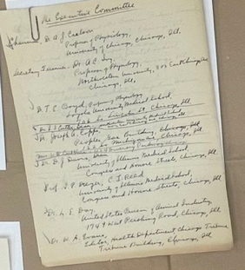 | “The Executive Committee,” ca. 1929  The Illinois Society for Medical Research Records  This list of the ISMR executive committee members in Ivy’s hand includes deans and faculty of the major Chicagoland medical schools, as well as city hospital wardens and public health officials. The presidents of the University of Chicago, Northwestern University, University of Illinois, and Loyola University served as honorary vice presidents.
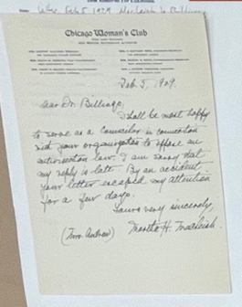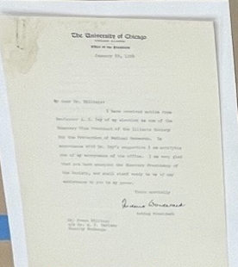  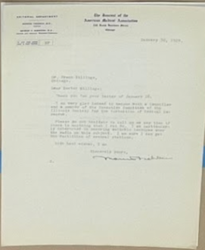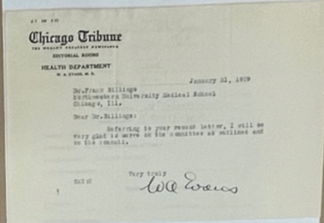  Some way to visually set off last sentence re: iPad in brackets? Different color or italics? | Letter, February 5, 1929  The Illinois Society for Medical Research Records  Letter, January 31, 1929  The Illinois Society for Medical Research Records  Letter, January 29, 1929  The Illinois Society for Medical Research Records  Letter, January 31, 1929  The Illinois Society for Medical Research Records  The ISMR recruited leaders with diverse spheres of influence. Women, Ivy once wrote, “lend moral support to our cause” and he enlisted the heads of several Chicago women’s clubs as councilors. Morris Fishbein, the editor of the Journal of American Medicine, helped secure favorable radio coverage.  [To hear broadcasts featuring the words of Carlson, Castle, and others, please visit the nearby iPad]
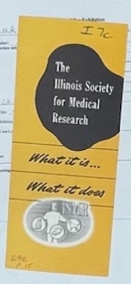  Possible pull quotes for this object/case:  “Above all, it should be remembered that the Illinois Society for Medical Research is an action organization.”  and/or:  “The program of the Illinois Society for Medical Research is a public information program. Through speakers, news stories, radio and television shows, films, and similar means of communication, it will provide for the public an account of the aims, the efforts and the achievement of medical science.” | “The Illinois Society for Medical Research: What It Is…What It Does”  Chicago: The Illinois Society for Medical Research, n.d.  The Illinois Society for Medical Research Records  The ISMR was loosely modeled on the Society of Friends of Medical Progress, a national organization founded in Boston in 1923. Both groups took a novel approach. In previous decades, the medical community had quietly defended animal experimentation when necessary. Now, doctors sought to actively educate the public on the importance of animal research through pamphlets and other promotional materials.
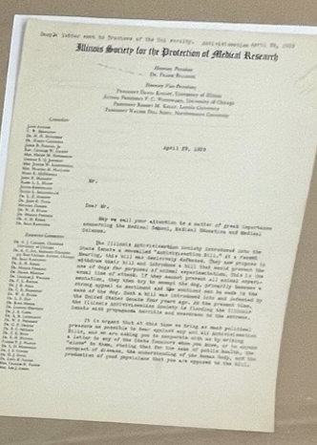 | Form letter, Illinois Society for the Protection of Medical Research to Its Members, April 29, 1929  The Illinois Society for Medical Research Records  In this early letter, the leaders of the ISMR announced their first legal victory—and their next challenge. A bill condemning vivisection of all kinds had been defeated in the State Senate, but a dog-specific bill was on the way. The society called on members to contact state senators and “bring as much political pressure as possible to bear” on the situation.
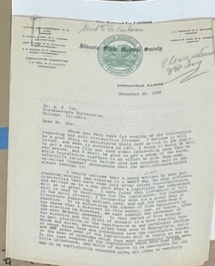 | Letter, Neal to Ivy, December 30, 1929  The Illinois Society for Medical Research Records  Neal was a frequent correspondent and close ally of the ISMR. Here, he informs Ivy that one senator had been offended by “what he termed the nauseating condition in which the kennels were kept” at Northwestern during a tour. Neal suggests that the rooms be “aired out as thoroughly as possible” before any future visits.

CASE NO. 3: The Courtney Bill
Today, scientists can purchase research animals from dedicated suppliers, but in the 1920s, there was no such thing as a scientific dog breeder in the United States. Researchers who needed dogs for their experiments had to find them, just as Bernard once had, on the streets of major cities. Municipal dog pounds were an especially attractive source. American dog ownership grew dramatically during the first half of the twentieth century as pet culture took on social and economic prominence, and many pounds were overflowing with lost and impounded dogs.
The so-called “Courtney Bill,” introduced into the Illinois State Legislature in 1929, would have prevented scientists from using dogs for experimentation whatsoever. For Carlson, Ivy, and others, it represented a fundamental threat to their work and the pursuit of scientific truth. They rallied support among members of the ISMR, wrote to many representatives, and held meetings with others in an effort to defeat the bill. Ultimately, they were successful, and the battle against Courtney signaled the emergence of the ISMR as a political force in city and state politics, exercising greater influence than any individual alone. The struggle against Courtney also gave its members a roadmap for future struggles, one which would soon prove useful.

Letter: Ivy to Carlson
Scientists faced a challenge in managing access to their facilities. On the one hand, many believed strongly in opening laboratories to the public to disprove charges that they were torturing dogs. On the other hand, they worried about antivivisectionists who might visit labs under false pretenses and provide misleading public testimony about laboratory practices and conditions.

Letter to Barbour
Early resistance to antivivisection bills primarily involved marshalling letters of support from prominent public figures that could be sent to legislators. Here, P. R. Shumway, the president of the Paper Mills Company in Chicago, writes to James Barbour after encouragement from Ivy and Dr. Irving Cutter, dean of the medical school at Northwestern.

Letter to Ivy about Courtney / Ivy to Neal
Courtney gradually distanced himself from the bill associated with his name, concerned that doctors throughout Chicago perceived him as an enemy of medical progress. He also disagreed with elements of Castle’s approach, which he considered overly confrontational. This letter, and the nearby letter from Ivy to John Neal, reveal the extent of the ISMR’s information gathering and its network of supporters.

“Vivisectionist Campaign On in Chicago”
The Illinois debates were initially local affairs, but they earned a national spotlight, as this clipping from Pasadena, California’s Star News shows. The two sides were starkly divided. “To our dog we are God,” proclaimed Irene Castle McLaughlin, while Chicago pathologist Ludwig Hektoen claimed that antivivisection was “a reversion to the ignorance of a former age.”
“Dog Has His Day in Council Chambers as Pros and Antis Debate Vivisection”
Dogs were not the only animals used in scientific research, but antivivisection advocates focused their message on their plight, hoping that emotional attachments to dogs would sway the public. “What do I care for pigs and mice!” proclaimed attorney John P. Snigg, “I’m talking for the good, faithful dog, the greatest friend man has.”

CASE NO. 4: IRENE CASTLE MCLAUGHLIN & CHICAGO’S ANTIVIVISECTIONIST MOVEMENT

Antivivisectionists in Chicago found a spirited leader with a knack for publicity in Irene Castle (1893-1969). A fashion icon and household name on both sides of the Atlantic during the Progressive era, Castle popularized modern ballroom dances with her partner and first husband, Vernon. Inveterate animal lovers, the Castles adopted a menagerie of pets including several monkeys, horses, a donkey, and more than a dozen dogs. Following Vernon’s untimely death in a plane crash in 1918, Castle continued to perform onstage, star in films, and collect animal companions.
Castle arrived in Chicago in 1923 when she married Frederic McLaughlin, a polo star whose father had founded a lucrative coffee import business in River North. More accustomed to parties in New York and holidays in southern France, Castle found Chicago society tedious and was unhappy in her marriage, which she later testified was rife with domestic abuse. Alienated from McLaughlin and his circle, Castle devoted herself to animal rights advocacy. In 1928, she founded Orphans of the Storm, a shelter and adoption center still active in Deerfield, Illinois, and became a vociferous defender of dogs following the passage of the Arvey Ordinance. A tabloid favorite, Castle received steady coverage and support from her friend William Randolph Hearst, whose newspaper the Chicago Herald and Examiner became a major outlet for antivivisection propaganda.

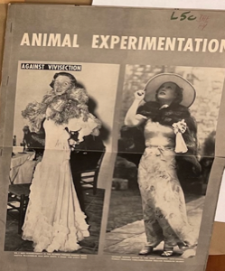  Pull quotes:  “A ban on animal experimentation would force surgeons to learn their art on living men and women.” —LIFE magazine  “Thanks to Miss Davies’ great and good friend, William Randolph Hearst, vivisection experiments have become front-page atrocity stories in the Hearst papers.” —LIFE magazine | “Animal Experimentation: Is It Essential to Medical Progress?” Life (October 24, 1938), 46.  The Illinois Society for Medical Research Records  Castle, the nation’s loudest opponent of vivisection, appears alongside her friend and Hearst’s companion, Marion Davies, in a Life magazine article that characterizes critics of animal research as elderly spinsters and restless matrons. Sexism was an enduring feature of twentieth-century debates over animal research—the medical community frequently painted its detractors as sentimental, irrational, and emotionally manipulative women of means.
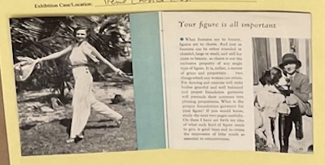 | Irene Castle (1893–1969)  Secrets of Rhythmic Living Every Woman Should Know  Chicago: The Formfit Company, 1933  Crerar Manuscripts V. 15 No. 12  A savvy entrepreneur, Castle parlayed her fame into several fashion partnerships. In the early 1930s, she became a brand ambassador for the Formfit Company and promoted its corset display at the Chicago’s World Fair. The endorsement was an unlikely one for Castle, who famously railed against girdles, narrow skirts, and other restrictive women’s attire during her dancing days.
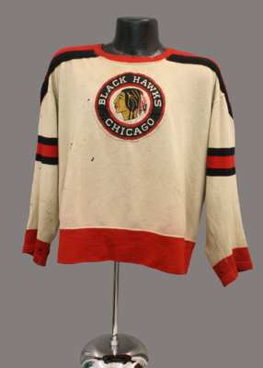  Vintage Blackhawks logo TK  https://exhibits.library.cornell.edu/biggest-little-fashion-city/feature/irene-castle-and-the-chicago-blackhawks | Castle’s husband, Frederic McLaughlin, bought the Portland Rosebuds in 1926 during a National Hockey League expansion. Known to all as “Major” following his military tour, McLaughlin renamed the team after his battalion, the Black Hawks—who, in turn, were named after the Sauk warrior who famously resisted the colonization of Illinois. Castle reportedly designed the original logo and uniforms.
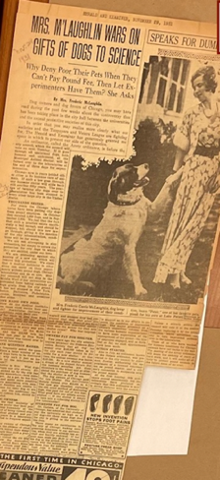  Pull quotes:  “If the poor man must pay $3.50 to release his dog at the pound—is there any reason why the laboratories should get these dogs for nothing?”  “Medical research will not stop in the Middle West if our universities are prevented from taking carloads of dogs gratis from the city pound.”  “We claim that if medical institutes in other cities can carry on their experiments without pound dogs, Chicago laboratories can do so also.” | “Mrs. M’Laughlin Wars on Gifts of Dogs to Science”  Chicago Herald and Examiner, November 29, 1931  The Illinois Society for Medical Research Records  Castle’s frustrations with Chicago society fueled her activism. She wrote in her 1958 memoir:  “The evening usually included a very dull dinner, a tremendous effort with food service and servants …They would stay until midnight, drinking enough of your best liquor to blot out the boredom of each other, and until they felt sufficiently fortified to shake your hand and lie about what a lovely evening it had been.”
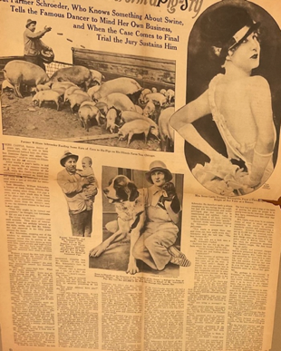 | “Mrs. Castle Reforms a Pig Sty”  American Weekly, November 1, 1931  The Illinois Society for Medical Research Records  Castle’s activism did not stop at stray dogs. In 1931, she had a pig farmer near her home in Lake Forest, Illinois arrested on animal cruelty charges. On a previous occasion, Castle rescued a performing bear from a vaudeville show and brought it to the Lincoln Park Zoo in a taxi.
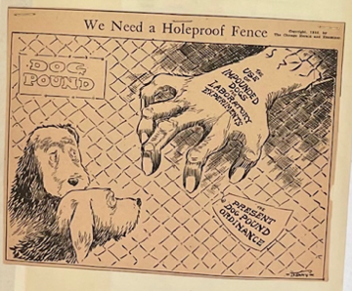  Some way to visually set off last sentence re: iPad in brackets? Different color or italics? | “We Need a Holeproof Fence”  Chicago Herald and Examiner, January 4, 1935  The Illinois Society for Medical Research Records  Hands and nets snaring helpless pups were popular motifs in the antivivisection propaganda published by the Chicago Herald and Examiner. The “caricature of a group of medical students and teachers lying in wait behind a high fence…ready to snatch some poor child’s puppy and rush him to the dissecting table,” Carlson insisted in a radio interview, “is ludicrous and fantastic.” [To listen to this broadcast, please visit the nearby iPad.]
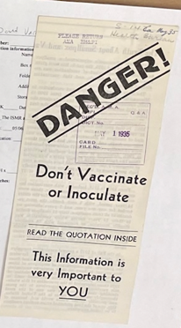 | “Don’t Vaccinate or Inoculate”  Minneapolis: The Health Bureau, May 14, 1932  The Illinois Society for Medical Research Records  A general distrust of doctors led many antivivisectionists to oppose vaccination. The authors of this pamphlet claim “there are the best of reasons to believe that vaccination actually causes smallpox,” although the data cited suggests otherwise.

PEDESTAL: THE ARVEY ORDINANCE

During the 1920s, the medical schools of Chicago enjoyed an unofficial arrangement with the city pound, which supplied doctors with unclaimed dogs for experimental purposes. Dr. Arno B. Luckhardt, a physiologist at the University of Chicago, for example, used strays to test ethylene as a general anesthesia. In January 1931, the University of Chicago sourced 329 dogs from the pound and Northwestern acquired 355.
Antivivisectionist groups dealt the medical schools a surprise blow in July 1931, when they secured the passage of a city ordinance that would have placed the pound under the control of antivivisectionists and cut off the supply of dogs.
The ISMR leapt into action and began lobbying aldermen to pass an amendment. Back in 1922, physiologists at Washington University Medical School in St. Louis had succeeded in passing an ordinance granting them access to impounded animals. Doctors involved in that effort encouraged their Chicago peers to pursue similar legislation. In subsequent hearings before the judiciary committee of the city council, the ISMR prevailed. Named for Alderman Jacob Arvey, the Arvey Ordinance passed on December 1, 1931.

Pullquote: “Whenever any reputable institutions of learning, hospitals or their allied institutes in the City of Chicago shall make applications…for permission to use humanely unclaimed impounded animals for the good of mankind and the increase of knowledge relating to the cause, prevention, control and cure of disease, the Commissioner of Health…shall request the Commissioner of Police to surrender said animals…” | The Arvey Ordinance  Chicago: Journal of the Proceedings of the City Council of the City of Chicago, Illinois.  December 1, 1931  The Illinois Society for Medical Research Records  Judging by the marginalia, this copy of the Arvey Ordinance was circulated among members of antivivisectionist groups during one of several repeal efforts. Critics of the ordinance frequently attacked it on economic grounds, arguing that it was unfair for tax-exempt universities to acquire dogs free of charge from a pound supported by taxpayers.

CASE NO. 5: THE FIGHT CONTINUES

Scientists hoped the passage of the Arvey Ordinance would put an end to their legal troubles, but Drs. Carlson, Ivy, and their associates found themselves fighting a near-constant battle for the next two decades. Ivy once estimated that, in the four years following the passage of the Arvey Ordinance, he spent nine months combatting legal challenges from Irene Castle, who launched multiple campaigns to repeal the measure and filed a series of injunctions against the city.
By enshrining the medical schools’ access to dogs, free of charge, the Arvey Ordinance enabled antivivisectionists to critique the economic preference given to Chicago’s universities instead of more abstract ethical aspects of animal experimentation. During the Depression era, Castle shrewdly framed her position in populist terms. “I can see no more reason why the city should give the universities their material for physiology classes than that they should make them a present of all confiscated cars, liquors, drugs, food supplies…as they might need for all their various studies,” she told one reporter. The “poor man,” Castle often argued, could not afford to retrieve his dog from the pound before it was claimed by doctors. The law, she said, favored both wealthy pet owners and institutions.
As the press devoted more space to the controversy, prominent doctors received a steady stream of hate mail and personal threats.

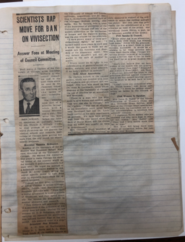  Pull quote:  “I represent 70,000 women who are mothers and who have dogs in many of our homes. They and I love babies more than we do dogs.”  - Dr. Lena Sadler | “Scientists Rap Move for Ban on Vivisection,” November 4, 1931.  The Illinois Society for Medical Research Records  Dr. Lena Sadler, a prominent physician identified here merely as a “club woman,” was among the medical community’s key witnesses in the hearings that led to the passage of the Arvey Ordinance. Choosing speakers was a delicate art. “I am more convinced than ever that the stage settings and local color, etc. and not the factual evidence play the most important role in determining the result of the Committee Hearings,” Ivy wrote to Carlson around this time.

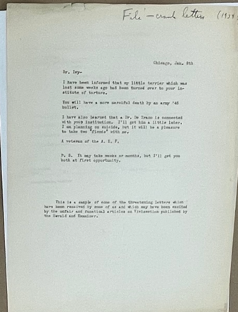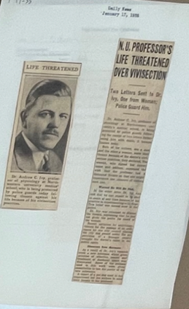  Pull quotes:  “It may take weeks or months, but I’ll get you both at first opportunity.”  and/or:  “The woman…expressed the wish that the professor had a thousand throats so that she might experience the pleasure of cutting each one.” | Letter, January 8, 1934?  The Illinois Society for Medical Research Records  “N.U. Professor’s Life Threatened Over Vivisection”  Chicago Daily News, January 17, 1935  The Illinois Society for Medical Research Records  When two antivivisectionists sent death threats to Ivy’s home, he blamed the “unfair and fanatical campaign” in the Chicago Herald and Examiner for stoking a violent fringe. Ivy wrote to an editor explaining that his wife was “very fearful lest some antivivisectionist lunatic will inflict personal damage on me or my children” but does not appear to have received a response.
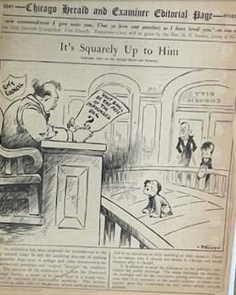  Pullquote: “What shall be the fate of the impounded dog?” | “It’s Squarely Up to Him”  Chicago Herald and Examiner, November 27, 1934  The Illinois Society for Medical Research Records  In 1934, Castle worked with Alderman Oscar F. Nelson to introduce a new ordinance that would prevent anyone from claiming impounded dogs except their owners. This cartoon features a society matron (the stereotypical antivivisectionist) and a little boy parted from his pet, modeled on the penniless children Castle frequently evoked in her campaigns.
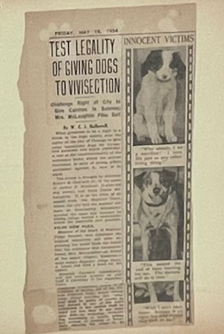  Pull quote:  “This means the end of bone hunting for me. The doctors will do it now.” | “Test legality of Giving Dogs to Vivisection,” May 18, 1934  The Illinois Society for Medical Research Records  Capitalizing on the emotional currency of children, as the doctors frequently did in their own campaigns, Castle filed an appeal on behalf of 11-year-old Arthur F. Koestner, whose dog slipped his collar and was taken to the city pound. The appeal challenged the constitutionality of the Arvey ordinance on several grounds.
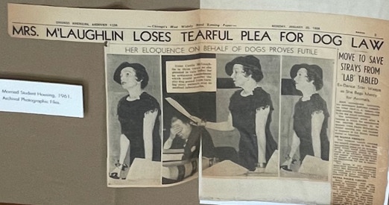  Pull quotes:  (The following are from different reports on the same hearing, but could maybe appear of plaques of their own near this one…)  “The city should not be in the business of operating the dog pound as a convenience to universities and hospitals.”  - Irene Castle, Chicago Daily Tribune (January 21, 1936)  “Her voice trembling and with tears streaming down her cheeks, the society matron…defended her humanitarian activities.”  - Chicago Herald and Examiner (January 21, 1936)  “Mrs. McLaughlin sat weeping quietly as the gallery, paying no attnetion to the gavel pounding of the committee chairman, roared and stamped in approval.”  - Chicago Herald and Examiner (January 21, 1936) | “Mrs. M’Laughlin Loses Tearful Plea for Dog Law”  Chicago American, January 20, 1936  Chicago newspapers made much of Castle’s emotional appearance before the city council during a tumultuous hearing on an amendment designed to override the Arvey ordinance. “I wonder where she conceals those powerful onions she uses for tear production in court,” one ISMR supporter quipped to Carlson in a letter after a session rife with cheering, jeering, and boos from the crowd.
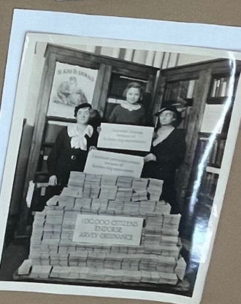 | Photograph, February 6, 1930  The Illinois Society for Medical Research Records  In the fall of 1930, the wives of Northwestern physiologists launched a campaign to demonstrate public support for the Arvey Ordinance. Over 150,000 people participated, and their cards form tall stacks in this photograph taken in Ivy’s office. Enlisting children who had survived diseases thanks to animal research, such as the girl posing here, was a popular tactic.

CASE NO. 6: Research and Dogs in Chicago

Early dog owners treated their pets very differently than we do, and few dogs lived especially long lives. A study in the 1950s found they were more likely to be killed by cars than reach eight years of age. Many dogs also ran loose on city streets, and Chicago pounds frequently collected more than 1,000 each month. These dogs were largely unvaccinated against ailments like rabies, a matter of special concern for people and dogs alike.
From the Latin word for madness, rabies was initially all but untreatable. Those bitten by rabid animals seemed to lose their very humanity in violent fits of rage, and the public had good reason to be cautious about loose dogs. But rabies also played an unexpected role in struggles over the use of pound dogs for research. Scientists in Chicago and elsewhere were using stunning numbers of dogs, for everything from surgical demonstrations to pharmaceutical testing, but many became increasingly concerned that these animals needed to be healthy and well cared for to produce useful results. As researchers grew more selective, expanded pound dog collection under the auspices of rabies management increased the quantity of viable animals.
Spurred by this realization, scientists reconfigured their relationship with municipal pounds. Rather than seeing them as reservoirs of valuable raw material, researchers reimagined pounds as proto-laboratory supply companies that could, if sufficiently incentivized, provide them the consistent flow of high-quality dogs they wanted for research.

“The Relation of Animal Hygiene to Public Health”
This report from the Agricultural Extension Service of the University of Illinois reveals the significant presence of animals in American life along with increasing awareness about how the health of animals affected the well-being of Illinois residents. Rabies appears as the sixth most communicable disease to man.

[Statistics on Impounded Dogs]
These statistics show the remarkable number of dogs caught by Chicago’s pounds. In 1934, the annual total was more than 9,000, nearly 3,000 of which were euthanized by pound workers. Scientists argued that these dogs were put to better use by serving in experiments, making a sacrifice for the pursuit of progress rather than being wasted.

“Care of Laboratory Animals”
By the 1950s, care for laboratory animals had become a central concern for scientists, worried both about experiments on unhealthy animals producing poor scientific results and about defusing critics of animal experimentation. Chicago-area researchers were leaders on the issue. The Animal Care Panel, today’s American Association for Laboratory Animal Science, met for their first national meeting in 1950 and began publishing an influential journal the next year.

Allocation of Dogs / Number of Dogs
Once researchers overcame the most immediate threat of legislation banning the use of dogs, they then faced the equally serious challenge of managing the dog supply. As this table demonstrates, Chicago-area workers used over 13,000 dogs per year in research and teaching, but desired nearly 3,000 more. Sourcing this many dogs was no easy feat.

CASE NO. 7: The NSMR and the National Battle

The organized work of the ISMR disarmed antivivisectionists in Illinois. By the early 1940s, its members also increasingly recognized themselves as components of a nationwide struggle. The National Society for Medical Research (NSMR) emerged in 1945 to unite that work and presented a stark choice to Americans—asking, would they support the continued march of science via animal research or return to darker times of superstition and death?
The NSMR shared this message in a newly published bulletin, which included standardized tactics for defeating local humane society legislation, as well as in radio broadcasts, pamphlets, newspapers, and magazines. Two threads of their argument proved difficult to resist. The Second World War had stressed the importance of advanced medical techniques, and the NSMR frequently presented military veterans, many now studying medicine on GI grants, in their campaigns against antivivisection legislation. The other line of argumentation looked forward to the future. The “Blue Baby” procedure, developed by Alfred Blalock, Helen Taussig, and Vivien Thomas at Johns Hopkins University, showed that infants with certain forms of congenital heart disease could be saved. First tested on dogs in Baltimore, the procedure was widely touted by members of the NSMR. Coming at the dawn of the baby boom, arguments for the necessity of saving America’s children were undeniably compelling.

“Your pet and medical research”
Antivivisectionists argued that scientists were so eager to use dogs in research that they stole pets, either intentionally or accidentally. To counteract these claims, researchers emphasized that animal experimentation benefitted not only human beings, but also the animals themselves in the form of scientific diets, vaccines, and veterinary procedures. This argument remains common in contemporary debates.

“Am I an Enemy of Animals?”
Scientists argued publicly that their work benefitted animals, and internal publications such as the NSMR Bulletin reinforced this message. Still, questions such as “Am I An Enemy of Animals?” also indexed genuine, ongoing anxieties about causing pain to animals in experiments.

“Which is Your Choice?” / “Which fate…”
The history of animal experimentation is often reduced to black-and-white dualisms, but antivivisectionists and researchers alike made use of stark binaries in their rhetoric. At a time when American support for basic science was at a historical high, scientists painted their opponents as enemies of civilization itself and gestured to antivivisectionist criticisms of vaccination as one justification.

“War and the Antivivisection Racket”
Capitalizing on American patriotism in the wake of World War II and during the subsequent Cold War, doctors made frequent use of soldiers in their promotional materials. Rejecting animal experimentation, they implied, meant condemning war heroes to death and disfigurement.

“The Legal Status of Animal Research in the United States”
Initially, many antivivisection struggles were local affairs. But quickly, scientists began to see themselves as part of a national struggle. This map, published circa 1950, makes clear that “use of unclaimed pound animals” was the defining goal of this national project, one that could be accomplished at both the city and state levels.

Carlson Time magazine cover
By 1941, Carlson was an internationally recognized authority in the life sciences whose reputation extended beyond biomedical circles. The cover art references his breakthrough cardiac research on horseshoe crabs at the Marine Biological Laboratory in Woods Hole, Massachusetts, that launched his career in 1904 while the caption (“Voss iss de effidence?”) alludes to his empirical drive and signature Swedish accent.

CASE NO. 8: The Debate at Midcentury

The middle of the twentieth century was a period of triumph for scientists who had struggled against organized antivivisection protests. Public opinion polling, itself a novel technology in American life, showed that citizens were largely convinced by arguments from researchers. Animal experimentation was essential to major medical breakthroughs, many believed, and they perceived critics as rich and out-of-touch socialites threatening the health of the common man. Researchers could also point to increasingly exacting standards for keeping animals in good health. Many began to wonder, at first quietly and then more publicly, whether the antivivisection movement had been defeated once and for all.
The answer was complicated. It was true that antivivisection was no longer effectively mobilizing public opinion in the way it once had. Fewer people were donning that particular mantle. But a new struggle against animal experimentation was also just around the corner, with critics beginning to couch their arguments in terms of animal rights and adopting new tactics to sway public perceptions of animal science.

“The Antivivisectionists and Animal Experimentation”
Morris Fishbein was an influential editor of the Journal of the American Medical Association and a vigorous proponent of animal experimentation. He used editorials to encourage doctors around the country to support access to research animals. In 1970, Fishbein endowed a center for the study of the history of science at the University of Chicago.

[Big Woman Holding Dog Cartoon]
Scientists relied heavily on stereotypes of the antivivisection movement as being led by a group of wealthy and unrelatable women threatening the lives of children. The truth was more complicated, but their messaging was effective in shaping public opinion. Here, a female antivivisectionist holds a confused dog and looks away, eyes closed, from the work of a doctor tending to an infant.

“Antivivisectionists—Are They Finished?”
The publishing magnate William Randolph Hearst played a vital role in magnifying the arguments of antivivisectionists in his newspapers—notably, Chicago’s Herald and Examiner. But following Hearst’s death in 1951, the antivivisection movement lost significant momentum, leading many scientists to wonder whether they were finally free of the threats that had occupied them for the past thirty years.

“Scampy and the Surgeon”
Although dogs were most frequently used to test new surgical techniques benefitting humans, they did occasionally serve as patients themselves. This article on a life-saving surgery performed on a pet dog at the University of Chicago was designed to contradict three central antivivisectionist claims: that animal experimentation was useless, that doctors treated the animals in their care cruelly, and that dogs were operated on without anesthesia.

ANDO CASE: A BATTLE OF IMAGES

Battles over animal experimentation played out in live debates at city clubs, through radio broadcasts, and at raucous public hearings. The most powerful means of communication for both sides, however, tended to be print media with eye-popping images. The National Society of Medical Research, founded by Carlson and Ivy in 1945 sought to promote the work of scientists by circulating photographs of healthy laboratory animals and to aggressively combat critics through new, and often humorous, pamphlets and publications. For antivivisectionists, images and purple prose were the most immediate way to convey the supposedly gruesome nature of laboratory work. Scientists became increasingly wary of spies within their laboratories—in one case, an antivivisectionist briefly employed as a laboratory technician at University of Chicago’s Billings Memorial Hospital delivered a lurid report of the atrocities he allegedly witnessed to the Chicago Herald American, which published a slew of articles on the subject. At the middle of the last century, questions of authenticity became increasingly critical to these debates as each side presented idealized or damning images of a controversial practice.

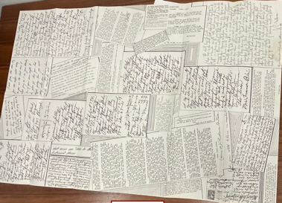 | Fan Mail for Scientists, ca. 1950  Chicago: National Society for Medical Research  The Illinois Society for Medical Research Records  “Well Merry Xmas and please I implore you kill yourself,” reads one of the notes from antivivisectionists collected here. Founded in 1948, the National Society for Medical Research countered antivivisectionist propaganda with pamphlets, advertisements, and a wry sense of humor. This collage of death threats and unhinged hate mail is typical of their efforts to portray antivivisectionists as crackpots harassing long-suffering heroes devoted to human welfare.
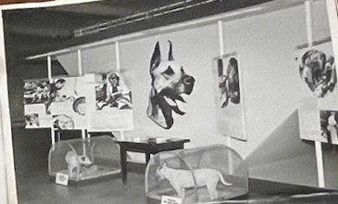  (Could do a joint plaque for this photo and following image if we have more flexibility with space/word counts in the ando case) | Photograph, February 6, 1946  “Really Man’s Best Friend, American Museum of Natural History, New York  The Illinois Society for Medical Research Records  “Really Man’s Best Friend,” an exhibition on medical breakthroughs derived from canine experiments, at the American Museum of Natural History opened with an award ceremony. The two laboratory dogs pictured here, Trixie and Josie, received the inaugural Whipple Prize recognizing “services to humanity.” Both dogs were descendants of those used by the prize’s namesake, Nobel laureate George H. Whipple, who helped develop liver therapy for pernicious anemia.
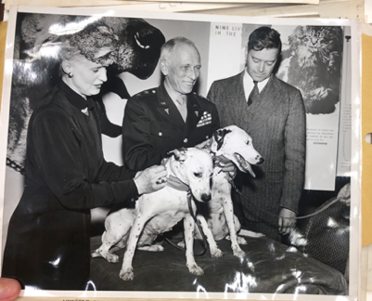 | Photograph, February 6, 1946  “Really Man’s Best Friend, American Museum of Natural History, New York  The Illinois Society for Medical Research Records  It was not uncommon during the Second World War and its aftermath for scientists to create military-style medals for laboratory animals to remind the public that American troops benefited from animal research. Here, Army Surgeon General Major General Norman T. Kirk awards silver collars to Trixie and Josie.
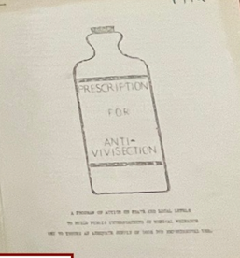 | Prescription for Anti-Vivisection, n.d.  The Illinois Society for Medical Research Records  [show multiple pages]  In this fascinating document, the medical community diagnoses the problems with its previous approach to antivivisectionists, including its tendency to answer their “fantasies in dead earnest.” Humor became a key part of the new strategy (on view in the nearby “Fan Mail for Scientists” pamphlet) as did increased transparency. Today, the medical community has returned to a quieter, less combative position on the need for animal experimentation.
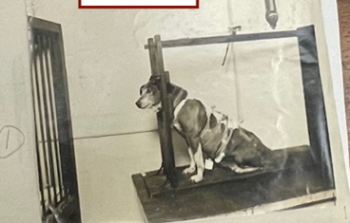 | Photograph, ca. 1923  The Illinois Society for Medical Research Records  Scientists and their supporters often countered charges of cruelty with references to Buster, a laboratory dog who lived at the University of Chicago for thirteen years. When this photo was taken, she was the only canine in the country whose stomach had been surgically divided according to a procedure developed by Nobel laureate Ivan Pavlov. The smaller section, no longer involved in digestion, still continued to secrete gastric juice, which was collected from a small opening in Buster’s abdomen.
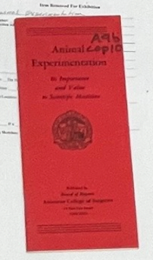  Pull quote:  “Would those who wish to deprive scientists of their weapons against disease advocate the disarmament of the entire police force of the United States, and the free play of gangsters against the public?”  - Carlson | Animal Experimentation: Its Importance and Value to Scientific Medicine  Chicago: Board of Regents, American College of Surgeons, n.d.  The Illinois Society for Medical Research Records  Pamphlets published in defense of animal experimentation often followed a similar formula, collecting statements from leading experts. This example features Ivy and Carlson, as well as authorities at the National Institute of Health, Harvard University, and the Mayo Foundation, among other institutions.
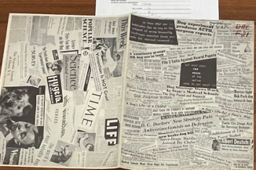 | “But What Does the Press of the Nation Have to Say About It?”, ca. 1949  The Illinois Society for Medical Research Records  The authors of the nearby “Prescription for Antivivisection” document report that roughly 10% of the public, “under the influence of colorful Hearstian fantasies,” opposes vivisection. Determined to show that the press was on their side, the medical community assembled these headlines and clippings from national magazines and local newspapers.
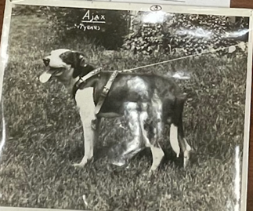 | Photograph (Ajax), n.d.  The Illinois Society for Medical Research Records  Ajax, a famous laboratory dog at Northwestern, died of natural causes in 1933 at the age of twelve. For ten of those years, as one reporter noted, “he never had a stomachache, because he had no stomach.” Removing stomachs from dogs led Ivy to conclude that humans with malignant cancer could, if necessary, also live without them. Ivy also used dogs to identify the hormone, gastrin, that triggers the release of gastric juice. Carlson, whose nickname was Ajax, was likely the dog’s namesake. A happy-looking dog, Ajax was regularly used to refute charges of cruelty. He appears with Ivy in the film projected on the gallery wall.
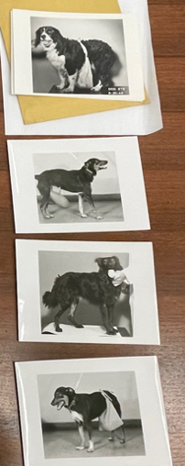 | Photographs, ca. 1953  The Illinois Society for Medical Research Records  Nathan Brewer, Carlson’s protégé at the University of Chicago, sent these photos to W. W. Bauer, director of the AMA Bureau of Health Education, for inclusion in an unknown project. “They are being returned,” Bauer wrote, “because all of them have elements which would not be acceptable to many lay observers. In colleges there are anti-vivisectionists and potential anti-vivisectionists, many of whom would be driven over the line by such pictures as these.”
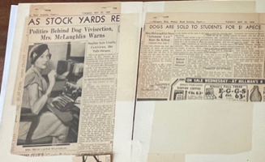  Pull quote:  “…YOUR dog pound is run as a collecting station for the medical schools and laboratories.” | “Politics Behind Dog Vivisection, Mrs. McLaughlin Warns”  Chicago American, May 22, 1934  The Illinois Society for Medical Research Records  A fashion icon once heralded as the best-dressed woman in America, Castle bobbed her hair as early as 1913, long before it became a Jazz Age style, and her dresses were widely copied at the height of her fame. A canny public figure, Castle posed for photos like this one knowing her image could boost public interest in her cause.
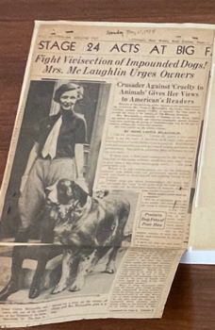 | “Fight Vivisection of Impounded Dogs! Mrs. McLaughlin Urges Owners”  Chicago American, May 21, 1934  The Illinois Society for Medical Research Records  During the Depression era, Castle frequently evoked class inequality in her attacks on the Arvey Ordinance. At the time, retrieving a dog from the pound cost $3.50 (nearly $30 today). This was a prohibitive sum for many families. Ironically, Castle and other prominent antivivisectionists belonged to the city’s upper crust. “We thinned out our stables and that was about the limit of our belt-tightening,” she wrote in her memoir.
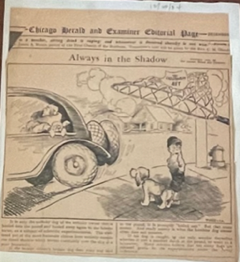 | “Always in the Shadow”  Chicago Herald and Examiner, December 20, 1934  The Illinois Society for Medical Research Records  The lapdog of a haughty-looking woman in a fur collar catches the eye of a scrappier pup at the mercy of the medical schools. Class differences were a significant feature of antivivisectionist attacks on the Arvey Ordinance. Scientists, meanwhile, frequently noted that the same people who protested animal experimentation often wore leather and fur, ate meat, hunted, and fished—activities they claimed caused far more animal suffering than medical research.
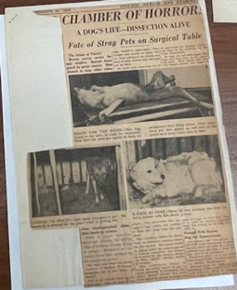  Pull quotes:  “…neighbors always know when the vivisectors are at work by the agonized howls that come from within.”  “In fetid air and foul cages, they…wait their turn on the operating table.” | “Chamber of Horror!”  Chicago Herald and Examiner, December 31, 1934  The Illinois Society for Medical Research Records  Writers for the Chicago Herald and Examiner were prone to florid exaggeration, but there appears to have been some truth to this exposé on Institute of Surgical Technique, a private experimental laboratory on Ogden Avenue. The Board of Health cut off the institute’s access to dogs following the publication of this grisly article, and alderman Jacob Arvey was reportedly indignant that his name was attached to the ordinance that made it possible.
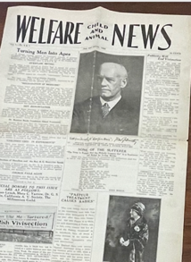  Pull quote:  “We live in an age of publicity, of propaganda, and of broadcasting. Whoever has anything to sell asserts the fact with stentorian tones loud enough to awake the seven sleepers of Ephesus.” | Child and Animal Welfare News, vol. I, no. 6-7  Philadelphia (1928)  The Illinois Society for Medical Research Records  The welfare of children and animals were often linked in humanitarian propaganda of the nineteenth and early twentieth century. Some activists claimed that animal cruelty, including medical research, could cause men to treat other vulnerable members of society cruelly as well.
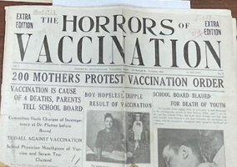  Pull quote:  “If priestcraft, in the form of medical craft, tries to tyrannize over you by attempts to operate on the beautiful body of your healthy child, fight the monster to a finish.” | The Horrors of Vaccination, Vol. 1 No. 2  Columbus, Ohio: Anti-Compuslory Vaccination Society (ca. 1924)  The Illinois Society for Medical Research Records  Antivaccination propaganda tended to focus on horrific reports and gruesome pictures of children who had allegedly contracted diseases, developed physical deformities, suffered mental deterioration, or died following their inoculation. This publication, which also contains a macabre report on how smallpox serum was supposedly derived from heinously cruel operations on calves, folds antivivisection into a larger antivaccination agenda.
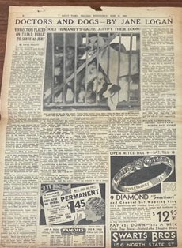  Pull quote:  “Doctors are now on trial, and these columns are the court. Readers were to act as the judge and jury.” | “Doctors and Dogs—By Jane Logan”  Daily Times Chicago, June 27, 1934  The Illinois Society for Medical Research Records  In the summer of 1934, a journalist using the pseudonym Jane Logan penned a fifteen-part series on the pound dog controversy in Chicago. Written a few months before Irene Castle’s third attempt to overturn the Arvey Ordinance in appellate court, Logan asked audiences to weigh the evidence for both sides. The series covered a wide range of topics, from the technique for lassoing stray dogs to the sixteenth-century experiments of Andreas Vesalius.
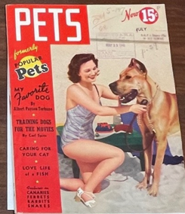  Pull quote:  “Animals in the laboratories…suffer less inconveniences than many a cherished pet abandoned to the over-enthusiastic affection of children.” | Pets, July 1940  The Illinois Society for Medical Research Records  Pet ownership boomed in the United States following the Second World War, creating a market for magazines like this one. Inside, W. W. Bauer, the director of the Bureau of Health Education, responds to an attack on animal experimentation in the previous issue with the headline “Murder for Science.” As dogs became members of the all-American family, antivivisectionists asked pet owners to imagine how they would feel if their own canine pal was lost to a laboratory.
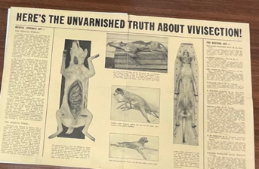 | “Here’s the Unvarnished Truth About Vivisection”  Chicago: The National Anti-Vivisection Society, n.d.  The Illinois Society for Medical Research Records  The authors of the more extreme antivivisectionist literature would sometimes mutilate dead dogs, stage photographs to simulate surgeries in progress, and claim these images depicted real experiments in university laboratories. Significantly, this pamphlet condemns research on insulin, a discovery the medical community frequently used as an argument for the necessity of animal experimentation.

